Typeform to Pipedrive — Lead & Deal Creation Automation

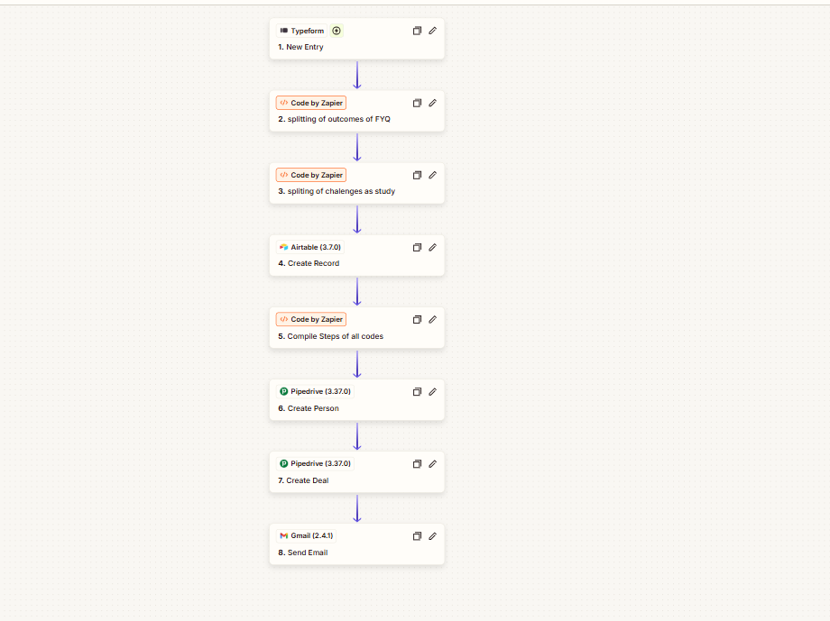

Project Description
A streamlined lead-processing automation that takes new Typeform submissions and turns them into organized Pipedrive records. The submitted information is first processed and prepared through Code by Zapier before being passed into Pipedrive, where a new person and associated deal are created.
This creates a simple path from form submission to sales pipeline, removing the need to manually transfer lead information between platforms. Typeform supports triggering workflows from new form entries, while Pipedrive can create person and deal records through Zapier.

Automation Scope
- Typeform new-entry trigger
- Lead data collection from form submissions
- Data compilation through Code by Zapier
- Lead data processing and formatting
- Pipedrive person creation
- Pipedrive deal creation
- Person-to-deal association
- Automated CRM record creation
- Typeform-to-Pipedrive data transfer
- Sales pipeline entry automation

Workflow
Typeform New Entry → Code by Zapier: Compile Steps of All Codes → Pipedrive: Create Person → Pipedrive: Create Deal
The workflow starts when a new Typeform response is submitted. The collected information is processed through the Code by Zapier step and then passed into Pipedrive to create the corresponding person and deal records. This gives each new submission a direct path into the CRM and sales pipeline.

Key Objective
Automatically turn Typeform submissions into structured Pipedrive contacts and deals, reducing manual data entry and making sure new leads move into the CRM and sales pipeline as soon as they submit the form.

